A PROJECT REPORT
ON
ADVANCE JAVA LAB

VyaparOS
Business Management System
Submitted in partial fulfillment of the requirement for the award of Degree of Bachelor of Technology in Computer Science & Engineering
Submitted to:



Rajasthan Technical University, Kota (Raj.)

Under the Guidance of
Er. Ram Babu Buri

Submitted By:
Jagrati Sahu (24EARAD064)
Koshi Jain (24EARAD082)
Navya Raj (24EARAD109)
Palak Sahani (24EARAD117)
Kumkum Rathore (24EARAD086)

 Department of Computer Science & Engineering

Session
:

2026
-
2
7
ARYA COLLEGE OF ENGINEERING & I.T.
SP-42, RIICO INDUSTRIAL AREA, KUKAS, JAIPUR



Department of Computer Science & Engineering

CERTIFICATE OF APPROVAL

The Project Report entitled “VyaparOS – Business Management System” submitted by “Jagrati Sahu (24EARAD064), Koshi Jain (24EARAD082), Navya Raj(24EARAD109), Palak Sahani (24EARAD117),Kumkum Rathore (24EARAD086)” has been examined by us and is hereby approved for carrying out the project leading to the award of degree “Bachelor of Technology in Artificial Intelligence and Data Science”. By this approval the undersigned does not necessarily endorse or approve any statement made, opinion expressed or conclusion drawn therein, but approve the pursuance of project only for the above mentioned purpose.

Mentor :
Er. Mukesh Mishra
Assistant Professor

Department of Computer Science & Engineering

CERTIFICATE

This is to certify that the work embodies in this Project entitled “VyaparOS” being submittedby“JagratiSahu(24EARAD064),Koshijain(24EARAD082),NavyaRaj(24EARAD109), Palak Sahani (24EARAD117),Kumkum Rathore (24EARAD086)”in partial fulfillment of the requirement for the award of “Bachelor of Technology in Artificial Intelligence and Data Science” to Rajasthan Technical University, Kota (Raj.) during the academic year 2025-26 is a record of bona fide piece of work, carried out by them under our supervision and guidance in the “Department of Artificial Intelligence and Data Science”, Arya College of Engineering & Information Technology, Jaipur.

Project Guide:
Er. Ram Babu Buri HOD
Associate Professor Dr. Akhil Pandey
Professor

Department of Computer Science & Engineering

DECLARATION

We “ Jagrati Sahu , Koshi Jain , Kumkum Rathore , Navya Raj , Palak Sahani”, students of Bachelor of Technology in Computer Science & Engineering, session 2026-27, Arya College of Engineering & Information Technology, Jaipur, here by declare that the work presented in this Project entitled “VyaparOS” is the outcome of our own work, is bona fide and correct to the best of our knowledge and this work has been carried out taking care of Engineering Ethics. The work presented does not infringe any patented work and has not been submitted to any other University or anywhere else for the award of any degree or any professional diploma.

Jagrati Sahu (24E1ARADF30P064)
Koshi Jain (24E1ARADF30P082)
Kumkum Rathore (24E1ARADF30P086)
Navya Raj (24E1ARCSF30P109)
Palak Sahani (24E1ARADF30P117)

Date: 16-10-2026

ABSTRACT

VYAPAAROS — Management System is a web-based application developed to simplify
and improve the daily operations of salon businesses. The system provides a centralised platform
to manage customer information, appointments, salon services, billing, payments, inventory, supp
-liers, and business activities through an organised and user-friendly interface. It aims to reduce
manual paperwork, improve operational efficiency, and help salon owners manage their business
more effectively.

The application is developed using Java, Spring Boot, MySQL, HTML5, CSS3, and JavaScript.
It includes features such as user authentication, role-based access control, customer management,
appointment scheduling, invoice generation, payment tracking, inventory monitoring, and business
reporting. The system distinguishes between Admin and Staff permissions to ensure that sensitive
information and administrative functions are accessible only to authorised users. The dashboard
presents important business information, while staff management and working-hour tracking
support better workforce organisation.

VYAPAAROS is designed to provide a convenient and structured approach to salon management
by integrating multiple business functions into a single web application. It helps minimise manual
errors, improves the accessibility of business records, and supports better decision-making through
organised data and reports. The project demonstrates how modern web technologies, database
management, and role-based security can be combined to develop an efficient and scalable solution
for salon businesses.

ACKNOWLEDGEMENT

We would like to express our sincere gratitude to our respected faculty members and project
guide for their valuable guidance, continuous support, and encouragement throughout the
development of our project, “VypaarOS — Business Management System.” Their suggestions
and feedback helped us understand the project requirements and improve our technical response.

We are thankful to the management and faculty of Arya College of Engineering and IT, Jaipur,
for providing us with the necessary resources and learning environment to work on this project.
We would also like to thank our department for giving us the opportunity to apply our
theoretical knowledge to a practical software development project.

We extend our appreciation to all our team members for their cooperation, discussions,
and contributions during the planning, design, development, and testing phases of the
project. Their teamwork helped us understand the importance of coordination, problem
-solving, and effective communication in software development.

Finally, we would like to thank our family and friends for their constant encouragement
and support throughout this project. This work has provided us with valuable experience
in web application development, database management, and collaborative project execution.

Thank you to everyone who contributed directly or indirectly to the successful
completion of this project.

TABLE OF CONTENTS

Section | Particulars | Page No.
1. | INTRODUCTION | 1
1.1 | Overview | 1
1.2 | Problem Statement | 1
1.3 | Objectives | 2
1.4 | Applications | 3
2. | SOFTWARE & TECHNOLOGY ARCHITECTURE | 4
2.1 | Technologies Used | 4
2.2 | Technology Specifications | 5
2.3 | Team Structure & Module Ownership | 5
3. | DESIGN & METHODOLOGY | 7
3.1 | System Architecture | 7
3.2 | Database Design | 8
3.3 | User Authentication & Role Management | 9
3.4 | Dashboard & Navigation Design | 10
3.5 | Testing & Validation | 11
4. | RESULT AND DISCUSSION | 12
4.1 | System Performance | 12
4.2 | Project Screenshots | 13-17
4.3 | Limitations Observed | 18
5. | CONCLUSION AND RECOMMENDATIONS | 19
5.1 | Conclusion | 19
5.2 | Key Achievements | 19
5.3 | Future Scope | 20
6. | APPENDICES | 21
A | Appendix A: System Diagrams | 21-23
B | Appendix B: Source Code | 24-29
7. | REFERENCES | 30

INTRODUCTION

  - Overview
VypaarOS is a web-based, full-stack Business Management System developed to simplify and streamline daily business operations. It is designed to help businesses manage their customers, appointments, services, billing, payments, inventory, suppliers, and expenses through a single,
integrated platform. The system provides a centralised environment where business information
can be stored, accessed, and managed efficiently, reducing the need for manual record-keeping.

The application integrates a user-friendly frontend with a Java Spring Boot backend and a
MySQL database to provide a structured and reliable business management experience. Its
dashboard present important business information, including customer details, appointment
schedules, revenue summaries, pending payments, and other operational statistics. The system
also supports user authentication and role-based access control to ensure that administrative
functions and sensitive business information are available only to authorised users.

The backend is developed using modern Java technologies, including Java, Spring Boot,
Spring Data JPA, and REST APIs, while the frontend uses HTML5, CSS3, JavaScript,
and Bootstrap to provide a responsive and interactive user interface. MySQL is used to store
and manage business data, including customer records, appointments, invoices, payments,
inventory details, and staff information.

VypaarOS aims to improve operational efficiency, minimise manual errors, and provide
better control over business activities. By combining multiple business functions into one
application, the system helps users organise daily tasks, maintain accurate records, and
make informed decisions based on available business information.

  - Problem Statement
Managing daily business operations manually can be time-consuming and difficult,
especially when customer records, appointments, billing, payments, inventory, and
expenses are maintained separately. Manual processes may lead to data duplication,
calculation errors, delayed updates, and difficulties in accessing accurate business
information.
There is a need for a centralised and user-friendly Business Management System that can:
1

- Maintain customer records and appointment details in an organised manner.
- Manage services, billing, invoices, and payment records efficiently.
- Track inventory, suppliers, and business expenses.
- Provide a dashboard for viewing important business information.
- Implement role-based access to protect sensitive information.
- Generate reports to support business monitoring and decision-making.

1.3 Objectives
The main objectives of this project are:

- To develop a web-based Business Management System using Java, Spring
Boot, MySQL, HTML5, CSS3, and JavaScript.

- To design a centralised database for managing customer records, appointments,
services, invoices, payments, inventory, suppliers, and expenses.

- To develop an interactive dashboard that displays important business information,
including appointments, revenue summaries, pending payments, and customer
statistics.

- To implement secure user authentication and role-based access control to distinguish
between Admin and Staff permissions.

- To provide staff management features that allow authorised administrators to manage
staff accounts and monitor working hours.

- To simplify billing, invoice generation, payment tracking, and inventory management
through an organised interface.

- To generate business reports that help users review transactions and monitor overall
business performance.

- To create a responsive and user-friendly interface with modern navigation that works
across desktop and mobile devices.

- To reduce manual paperwork, minimise data-entry errors, and improve the efficiency
of daily business operations.
2
1.4Applications
The major applications of VypaarOS are:
- Small and Medium-Sized Businesses: Centralised management of customers,
transactions, services, and daily operations.

- Retail and Service Businesses: Management of customer information, service
records, billing, and payments.

- Appointment-Based Businesses: Scheduling appointments, maintaining customer
records, and tracking upcoming bookings.

- Inventory Management: Monitoring stock availability, maintaining supplier details,
and organising inventory records.

- Financial Record Management: Tracking invoices, payments, expenses, and
revenue-related information.

- Staff Management: Managing employee accounts, assigning access
permissions, and monitoring working hours.

- Business Reporting: Viewing organised business data and reports to support
operational planning and decision-making.

- Digital Business Administration: Replacing scattered manual records with a
centralised web-based platform accessible to authorised users.

3

SOFTWARE & TECHNOLOGY ARCHITECTURE

2.1 Technologies Used
Component | Technology | Role in System
Programming Language | Java | Implements business logic and backend processing.
Backend Framework | Spring Boot | Develops REST APIs and manages backend operations.
Data Access | Spring Data JPA | Handles database operations and entity mapping.
Database | MySQL | Stores customer, staff, appointment, billing, and inventory records.
Build Tool | Maven | Manages project dependencies and builds the application.
User Interface | HTML5, CSS3, JavaScript | Creates the application pages and interactive interface.
UI Framework | Bootstrap | Supports responsive layouts and reusable UI components.
API Communication | REST APIs | Connects the frontend with backend services.
Security | Authentication and Role-Based Access Control | Access ControlRestricts access to authorised users according to their roles.
Development Tools | Eclipse, Antigravity, Git, GitHub | Supports coding, project development, version control, and collaboration.

4

2.2 Technology Specifications

- Programming Language: Java is used to implement the application's business logic,
backend processing, and application services.
- Backend Framework: Spring Boot provides the application structure, REST API
development, dependency management, and backend service integration.
- Database: MySQL is used as the relational database for storing and managing customer information, appointments, services, invoices, payments, expenses, inventory, suppliers,
and staff records.
- Data Access Layer: Spring Data JPA simplifies database operations by mapping Java
entities to database tables and supporting data retrieval, insertion, updating, and deletion.
- Frontend Technologies: HTML5 structures the web pages, CSS3 provides styling and
layouts, and JavaScript enables interactive elements and dynamic data presentation.
- UI Framework: Bootstrap helps create a responsive user interface that adapts to desktop
, tablet, and mobile screens.
- API Communication: REST APIs enable communication between the frontend and
Spring Boot backend, allowing the application to exchange business data.
- Authentication and Security: The application uses login authentication and role-
based access control to separate Admin and Staff permissions. Sensitive operations
should be validated on the backend to prevent unauthorised access.
- Build Tool: Maven manages Java dependencies, project configuration, and application packaging.
- Version Control: Git and GitHub support source-code management, change tracking, and collaboration among team members.

2.3 Team Structure & Module Ownership
The VypaarOS Business Management System is developed by a five-member team.
Each team member is assigned specific responsibilities and modules to ensure
organised devlopment,effective collaboration, and smooth integration of the application.

The roles and responsibilities of each team member are described below:

5

Team Member | Assigned Role | Core Module Ownership
Jagarti Sahu | Backend Development & Security | Spring Boot setup, MySQL database, user authentication, Admin and Staff roles, Spring Security, and common APIs.
Koshi Jain | Billing & Finance | Invoice generation, service billing, tax and discount calculations, payment tracking, expense management, and revenue and profit calculations.
Kumkum Rathore | Inventory Management | Product and supplier management, stock-in and stock-out records, low-stock detection, purchase records, and inventory APIs.
Navya Raj | Frontend & Dashboard | Login UI, navigation, dashboard design, customer and appointment interfaces, billing and inventory pages, reports, charts, and backend API integration.
Palak Sahani | Customers & Appointments | Customer records, customer search and history, salon services, appointment booking, rescheduling, cancellation, and appointment status management.

Team Coordination
The team follows a modular development approach in which each member is responsible
for a specific functional area. The backend member supports database connectivity, authenticat
-ion, security, and common API development, while the other members develop their respective
business modules. Member 5 focuses on integrating these modules through a consistent user
interface and dashboard. Regular discussions and integration testing help ensure that the
different components work together as a unified Business Management System.

6

3. DESIGN & METHODOLOGY

3.1 System Architecture
VyaaparOS follows a layered architecture designed to manage business operations
through a unified web application. The presentation layer uses HTML5, CSS3, JavaScript,
and Bootstrap to provide the homepage, login interface, dashboard, and business management
modules. The controller layer handles incoming requests through backend APIs. The business
logic layer manages customer records, appointment scheduling, billing, payments, inventory,
staff attendance, and reporting. The data layer stores and retrieves business information using a
relational database such as MySQL.

The frontend communicates with the backend through HTTP requests and receives responses
containing the requested information. The backend validates user input, processes business
operations, and interacts with the database to maintain consistent records. Authentication and
role-based access control help restrict administrative operations to authorised users.

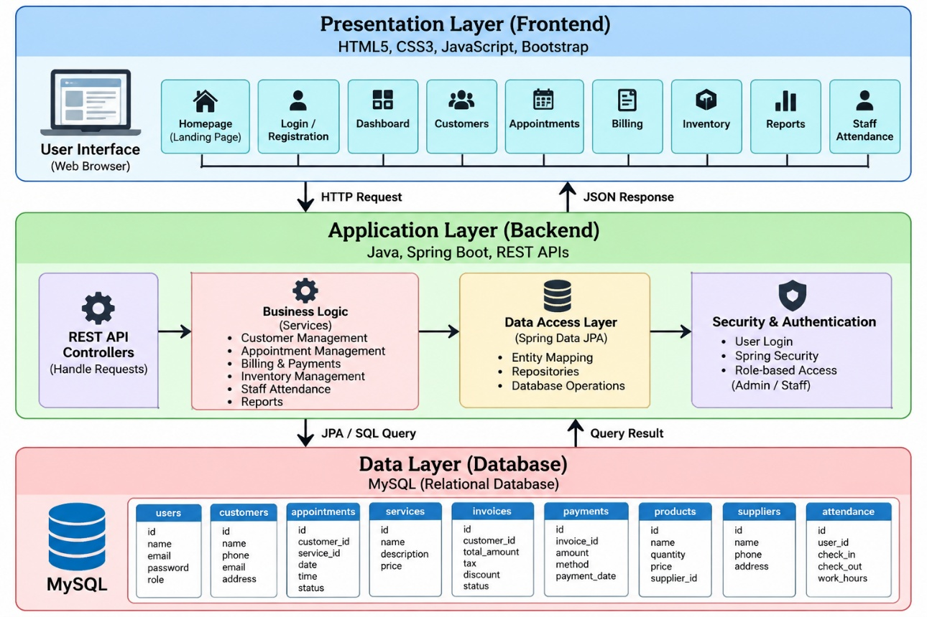

Figure 3.1: System Architecture (Layers)

7
3.2 Database Design
The database schema of VyaaparOS is designed to organise business information into
structured tables. The database may include tables for users, customers, appointments,
services, invoices, payments, products, suppliers, attendance, and expenses. Each table
stores information related to a specific business function.

The users table maintains account details and user roles. The customers table stores
customer information, while the appointments table records booking details and appointment
status. The services table maintains service names and prices. The invoices and payments
tables maintain billing information and payment transactions. The products and suppliers tables
support inventory management, while the attendance table records staff working hours
Primary keys uniquely identify records, and foreign keys establish relationships between
related tables. For example, an invoice may reference a customer, and a payment may
reference its corresponding invoice. These relationships help maintain data consistency
and support efficient retrieval of business information.
Table | Purpose
Users | Stores login credentials, user details, roles (Admin/Staff), and account status.
businesses | Stores business name, owner details, contact information, and business settings.
customers | Maintains customer names, phone numbers, email addresses, and other customer details.
services | Stores service names, descriptions, prices, and duration.
appointments | Records customer bookings, appointment dates, times, assigned staff, and status.
invoices | Stores invoice numbers, customer details, invoice totals, taxes, discounts, and payment status.
invoice_items | Stores individual services or products included in each invoice, including quantity and price.
payments | Records payment amounts, payment methods, dates, and transaction status.
products | Stores product names, categories, prices, available quantities, and low-stock thresholds.
suppliers | Maintains supplier names, contact details, and addresses.
attendance | Stores staff clock-in time, clock-out time, working hours, and attendance status.
expenses | Records expense categories, amounts, descriptions, and dates.

Table3.1: Database Tables and Their Purpose

3.3 User Authentication & Role Management

VyaaparOS provides a login interface to allow users to access the business management
system. Authentication verifies the submitted credentials before granting access to protected
resources. The system is designed to distinguish between Admin and Staff roles according to
their responsibilities.

The Admin role can be assigned administrative privileges, such as managing staff accounts and
accessing restricted business operations. The Staff role can be limited to the modules required for
daily work. These permissions should be enforced by the backend so that unauthorised users
cannot access restricted APIs by directly sending requests.

Login validation should reject incorrect credentials, and protected operations should require an
authenticated user with the appropriate permissions. Logout functionality should end the user's
authenticated session or invalidate the relevant authentication token, depending on the
implementation.
Role | Access Level
Admin | Administrative functions and authorised business management operations
Staff | Permitted operational modules according to assigned access rights
Table 3.2: Role-Based Access Control

The authentication system should be tested using valid credentials, invalid credentials,
logout scenarios, and attempts to access restricted operations.

3.4 Dashboard & Navigation Design
The VyaaparOS dashboard provides a central interface for accessing the system's business
management modules. Its design focuses on simple navigation, organised information, and
ease of use. The navigation structure allows users to move between available modules without
repeatedly returning to the homepage.

9
The dashboard may display important business indicators such as appointments, customer
records, revenue, pending payments, and inventory status, depending on the implemented
functionality. Customers, Appointments, Billing, Inventory, Staff Attendance, and Reports
are organised as separate functional modules.

HTML5, CSS3, JavaScript, and Bootstrap can be used to create the interface and support
responsive layouts. Consistent navigation elements, readable text, clear buttons, and organised
sections improve usability. Access to individual modules should depend on the user's role
and permissions.

The dashboard aims to reduce the effort required to manage business activities and provide
a convenient overview of important operational information.

3.5 Testing & Validation
Testing and validation are performed to verify that VyaaparOS behaves according to its functional
requirements. Each module should be tested individually, followed by integration testing to ensure
that the frontend, backend, and database communicate correctly.

Functional testing checks customer management, appointment scheduling, invoice generation,
payment tracking, inventory operations, and staff attendance. Authentication testing verifies valid
and invalid login attempts, while role-based access testing checks whether Staff users are preven
-ted from performing Admin-only operations.

Input validation testing examines missing fields, invalid values, and duplicate records. Database
testing verifies that information is stored, updated, retrieved, and deleted correctly. Business rule
testing checks calculations, appointment conflicts, payment balances, and stock restrictions wherever
these features are implemented.
Test Case | Expected Result
Login with valid credentials | User gains authorised access
Login with invalid credentials | Access is rejected
Staff attempts an Admin-only operation | Access is denied

10
Test Case | Expected Result
Add a customer record | Customer information is saved
Generate an invoice | Correct invoice details are displayed
Record a payment | Payment information is stored correctly
Update inventory | Stock quantity is updated according to the transaction
Access the deployed website | Available pages load correctly

Table 3.3: Testing Scenarios

Testing results should be recorded after executing each test case. Any errors identified during testing
should be corrected and the affected functionality tested again.

Overall, the testing process helps improve the reliability, consistency, and usability of VyaaparOS.

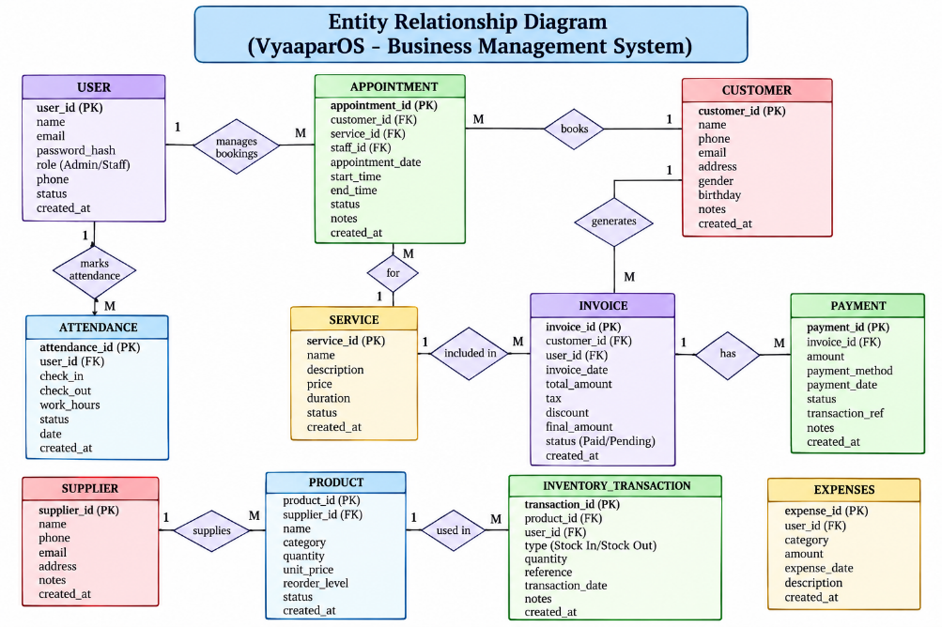

Figure 3.2: Entity Relationship Diagram of VyaaparOS
11

4. RESULT AND DISCUSSION

4.1 System Performance
VyaaparOS is a web-based Business Management System developed to simplify and organise daily business operations through a unified platform. The system provides a centralised interface for managing customers, appointments, services, billing and invoices, products and stock, staff attendance, expenses, and business reports.

The dashboard presents important business information, including invoiced revenue, cash collected, recorded expenses, and operating profit. It also provides sections for expense breakdown, staff attendance status, today's appointments, and low-stock product alerts. These features help users access relevant business information from a single interface.

The modular design separates different business functions, making navigation and maintenance easier. The system is intended to reduce manual record-keeping, minimise data-entry errors, and improve the accessibility of business records.

The overall performance of VyaaparOS depends on the response time of the application, database connectivity, the volume of stored records, and the reliability of the hosting environment. Functional testing of login, data management, billing, attendance, and inventory operations is necessary to evaluate its performance accurately.

Overall, VyaaparOS provides a structured approach to business management by bringing multiple operational activities together in one application. Further performance evaluation can be carried out using response-time measurements, functional test results, and user feedback.

4.2 Project Screenshots

12

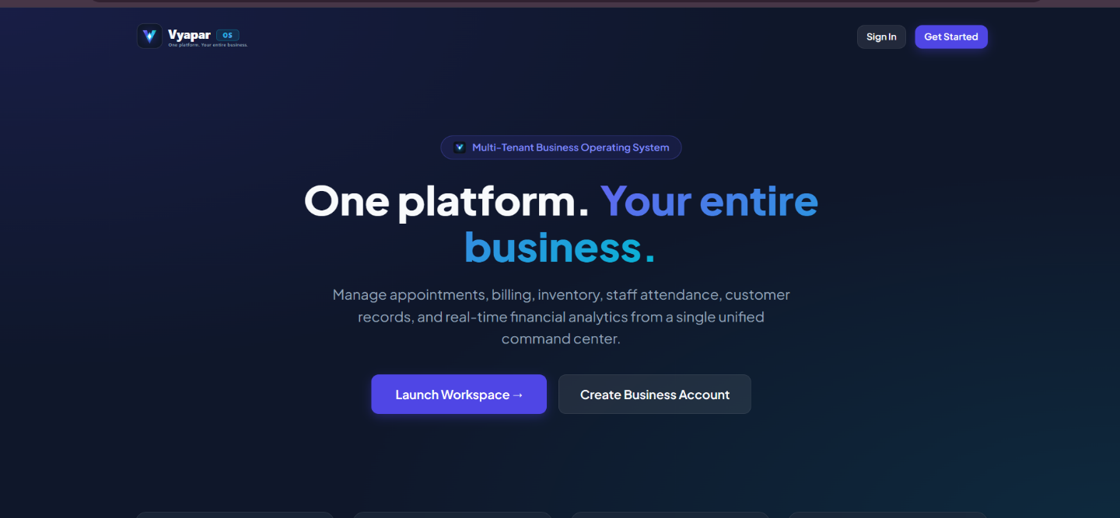

Figure 4.1: VyaparOS Home Page
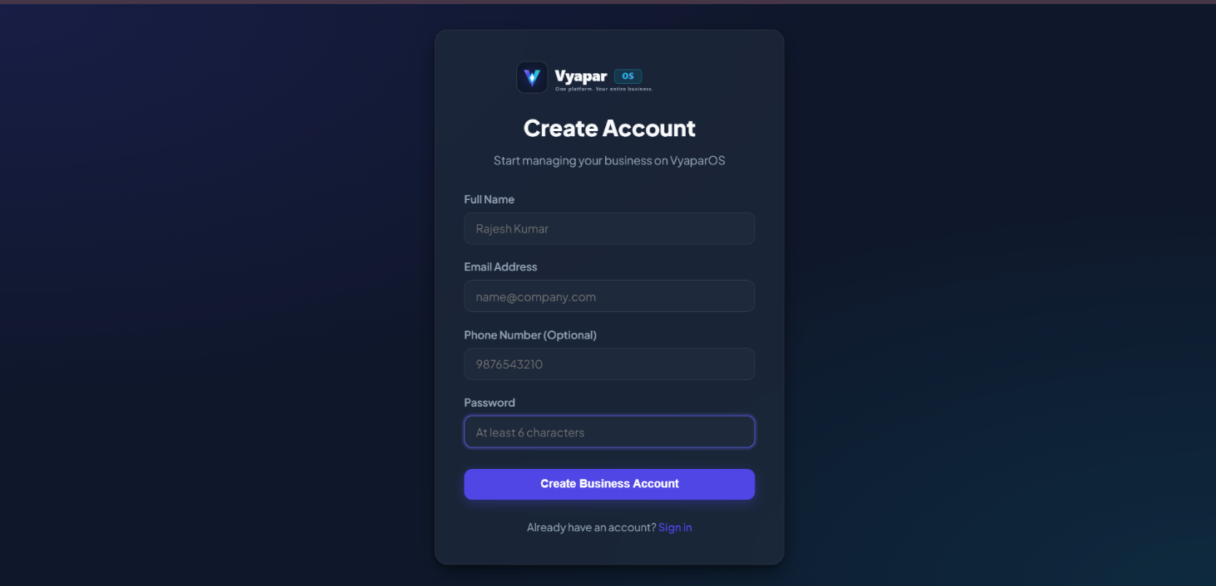

Figure 4.2: User Registration Page

13

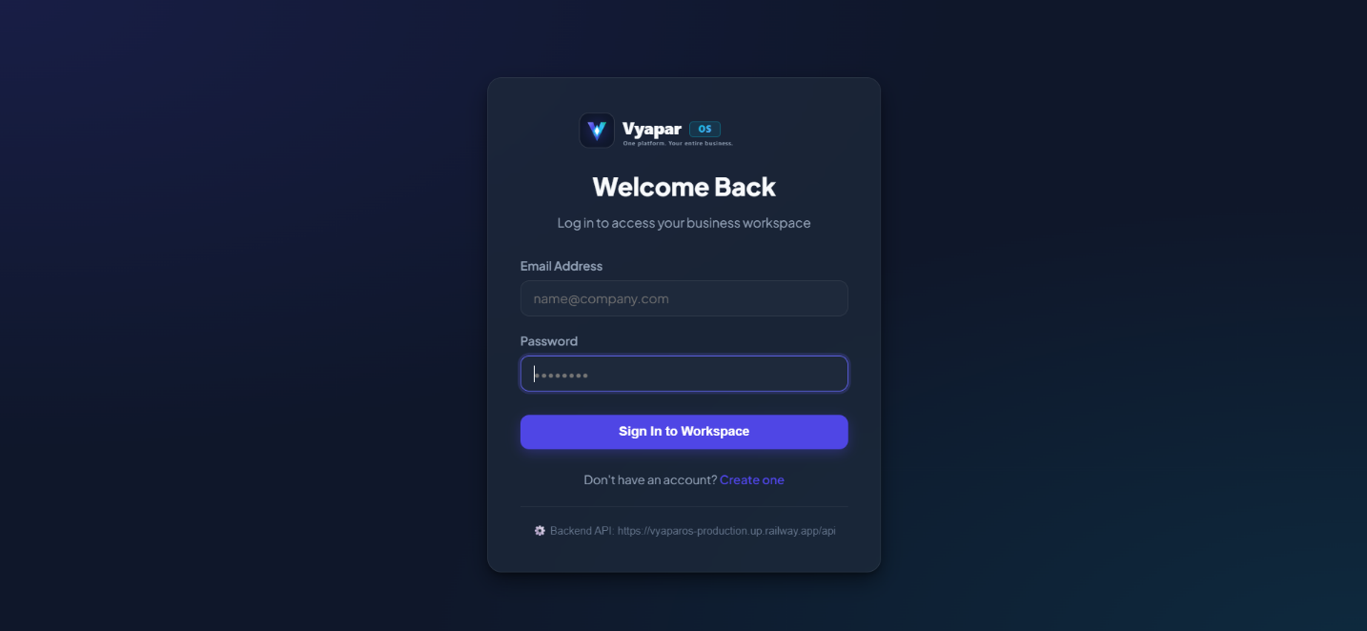

Figure 4.3: User Login Page

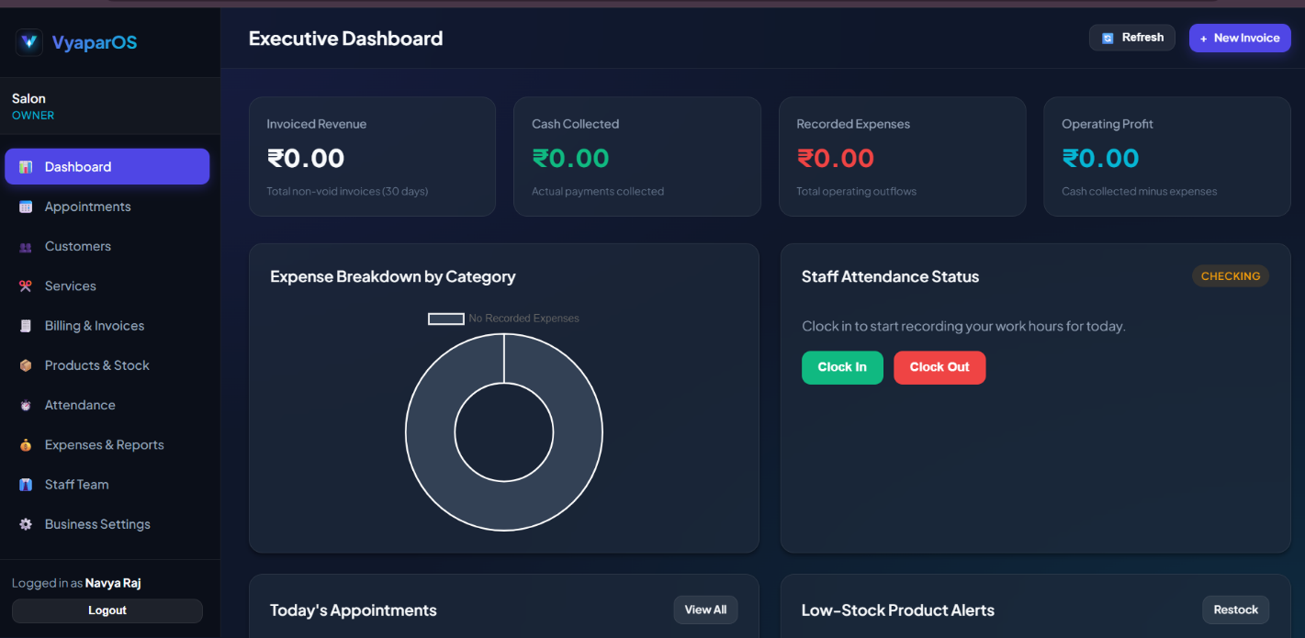

Figure 4.4: Executive Dashboard

14

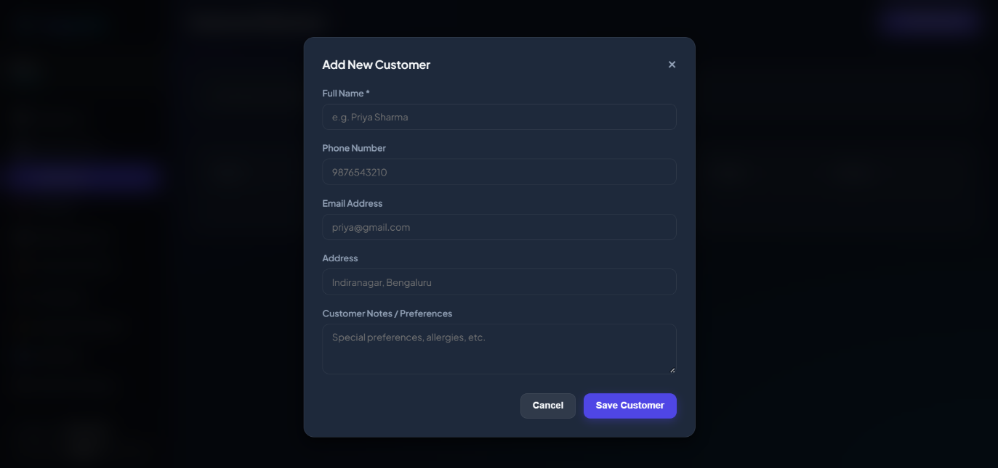

Figure 4.5: Add New Customer Interface

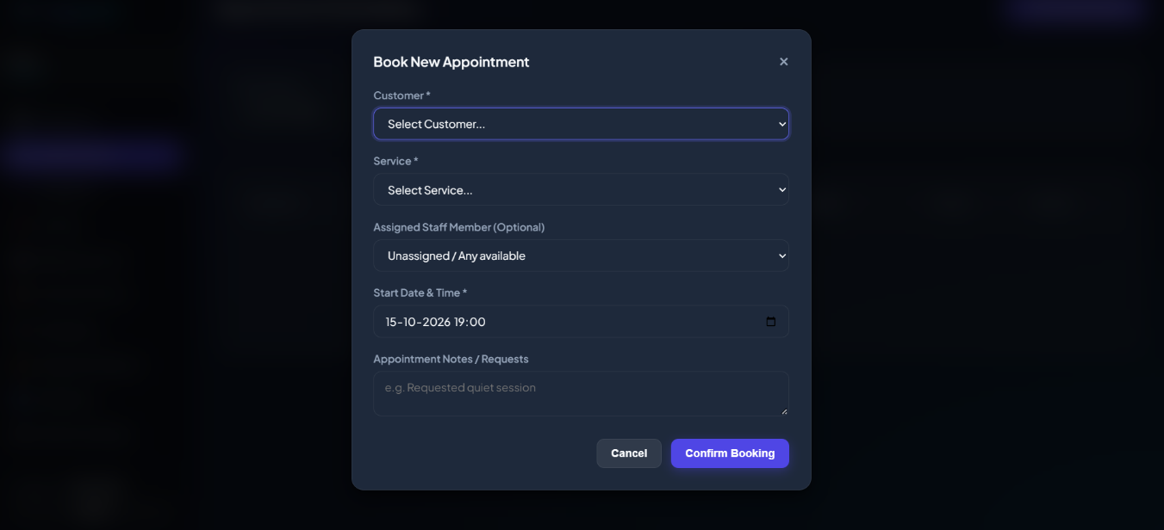

Figure 4.6: Appointment Booking Interface

15

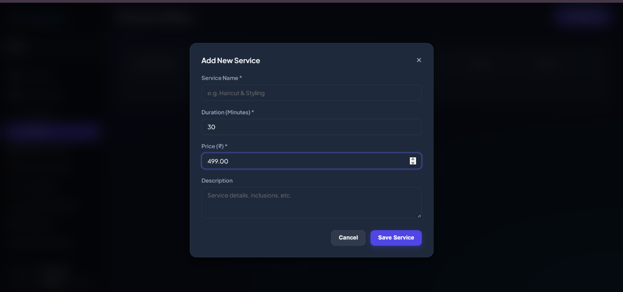

Figure 4.7: Add New Service Interface

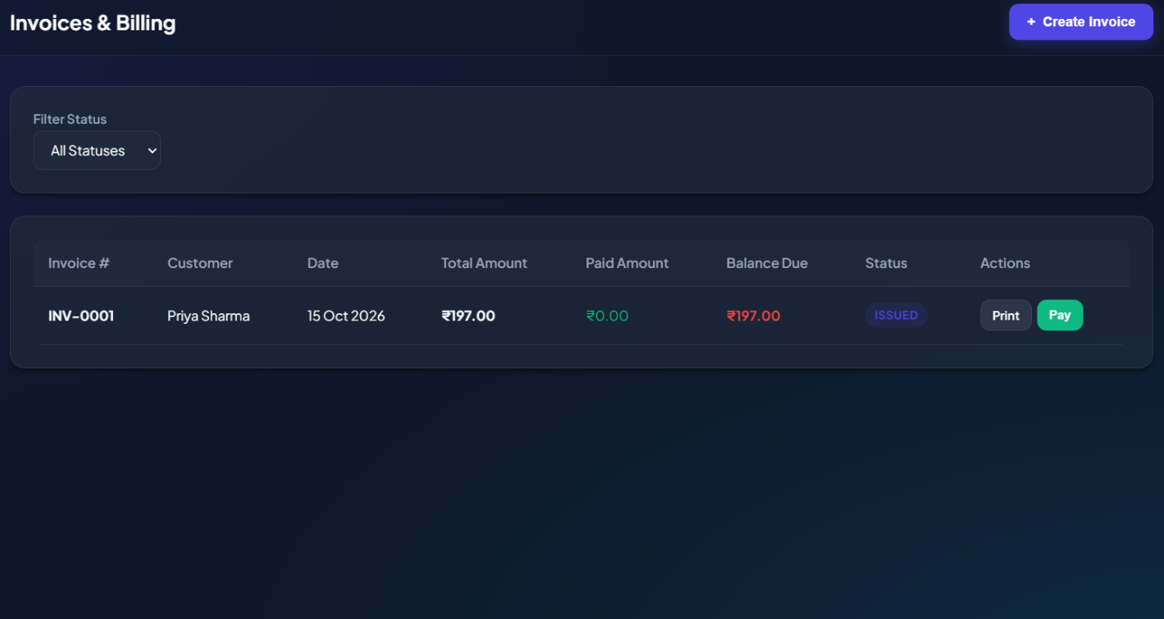

Figure 4.8: Billing and Invoice Management

16

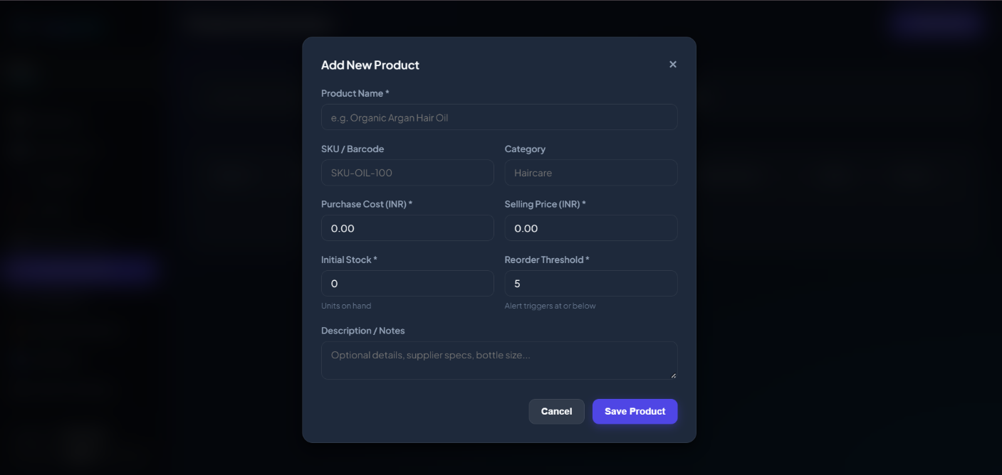

Figure 4.9: Add New Product and Inventory Interface

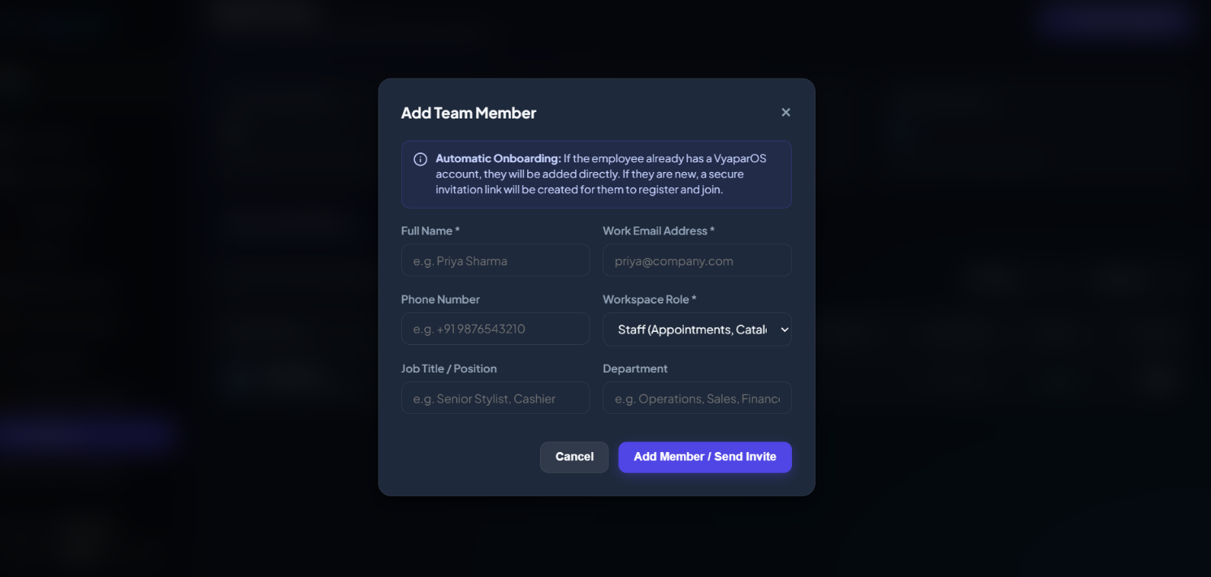

Figure 4.10: Staff Member Management Interface

17
4.3 Limitations Observed
Although VyaaparOS provides a unified platform for business management, certain limitations may be observed during development and deployment.
- Internet Dependency: As a web-based application, access to the live system depends on a stable internet connection and the availability of the hosting service.

- Backend and Database Availability: The application's functionality depends on successful communication between the frontend, backend APIs, and database. Connectivity or configuration issues may prevent some operations from working correctly.

- Role-Based Access Control: Admin and Staff permissions must be correctly configured and enforced by the backend. If permissions are not implemented properly, unauthorised access to restricted operations may be possible.

- Data Accuracy: The accuracy of dashboard metrics, invoices, payment records, and reports
depends on the correctness and completeness of the data entered into the system.

- Performance with Large Data Volumes: As the number of customers, appointments, invoices
, and inventory records increases, database queries and dashboard loading may require
optimisation.

- Limited External Integrations: Features such as online payment gateways, SMS notifications, email alerts, and third-party accounting integrations may require additional development and configuration.

- Security and Data Backup: The application requires appropriate password protection, secure communication, access controls, and regular database backups to protect business information.

- Testing Scope: The reliability of the application depends on the extent of functional, integration, security, and deployment testing performed. Untested scenarios may still contain defects.
These limitations identify areas for future improvement. Enhancements such as database optimisation, stronger security controls, automated backups, improved testing, and additional integrations can help make VyaaparOS more reliable and scalable.

18
5. CONCLUSION AND RECOMMENDATION
5.1 Conclusion
VyaaparOS successfully demonstrates how modern web technologies, including Java, Spring Boot,
Spring Data JPA, REST APIs, and MySQL, can be integrated with an interactive HTML, CSS, and Java
-Script frontend to develop a comprehensive Business Management System. The system provides
a unified platform for managing customers, appointments, services, billing, invoices, inventory, staff
attendance, expenses, and business reports.

The application offers a centralised dashboard that helps business owners monitor important
business activities, including invoiced revenue, cash collected, recorded expenses, and opera
-ting profit. It also provides features for customer management, appointment scheduling, invoice
generation, stock monitoring, and staff management through a user-friendly interface.

VyaaparOS aims to reduce manual paperwork, improve record management, minimise
calculation errors, and support efficient business operations. By integrating multiple
business functions into a single platform, the system helps simplify daily administrative
tasks and provides a foundation for better business planning and decision-making.

5.2 Key Achievements
- Developed a web-based Business Management System using Java, Spring Boot,
MySQL, HTML, CSS, and JavaScript.
- Designed an interactive dashboard to display financial information, business
activities, and important operational details.
- Implemented customer management functionality to maintain customer information,
contact details, and preferences.
- Developed an appointment management interface to support appointment booking
and service selection.
- Created a billing and invoicing module to manage invoices, payment status, total
amounts, and outstanding balances.
- Designed an inventory management interface to maintain product information,
stock quantities, prices, and low-stock alerts.
- Incorporated staff attendance functionality with clock-in and clock-out options
for recording working hours.
- Developed an expenses and reports section to help monitor business expenditure
and financial performance.
- Created a modern, responsive user interface with consistent navigation and organised information.
- Deployed the application online to make the system accessible through a web browser.
19
5.3 Future Scope
- Advanced Analytics: Introduce detailed financial analytics to identify business trends
and support better decision-making.

- Online Payment Integration: Integrate secure payment gateways to support online
payments and simplify transaction management.

- Automated Notifications: Add email and SMS notifications for appointment reminders, payment due dates, and low-stock alerts.

- Enhanced Security: Strengthen authentication, password protection, and role-based
access control to protect business information.

- Mobile Application: Develop an Android and iOS application to allow business
owners and staff to manage operations through mobile devices.

- Advanced Reporting: Generate downloadable PDF and Excel reports for invoices,
expenses, sales, inventory, and staff attendance.

- Inventory Improvements: Introduce supplier purchase management, automated
stock updates, and improved stock forecasting.

- Cloud Database and Backup: Implement automated database backups and recovery mechanisms to improve data availability and reliability.

- Multi-Business Support: Expand the platform to support multiple businesses with separate data, users, and business settings.

- Performance Optimisation: Optimise database queries and backend APIs to improve response time and support larger volumes of business data.

Overall, these improvements can help make VyaaparOS more secure, scalable, efficient, and
suitable for a wider range of business requirements.

20

6. APPENDICES

Appendix A: System Diagrams

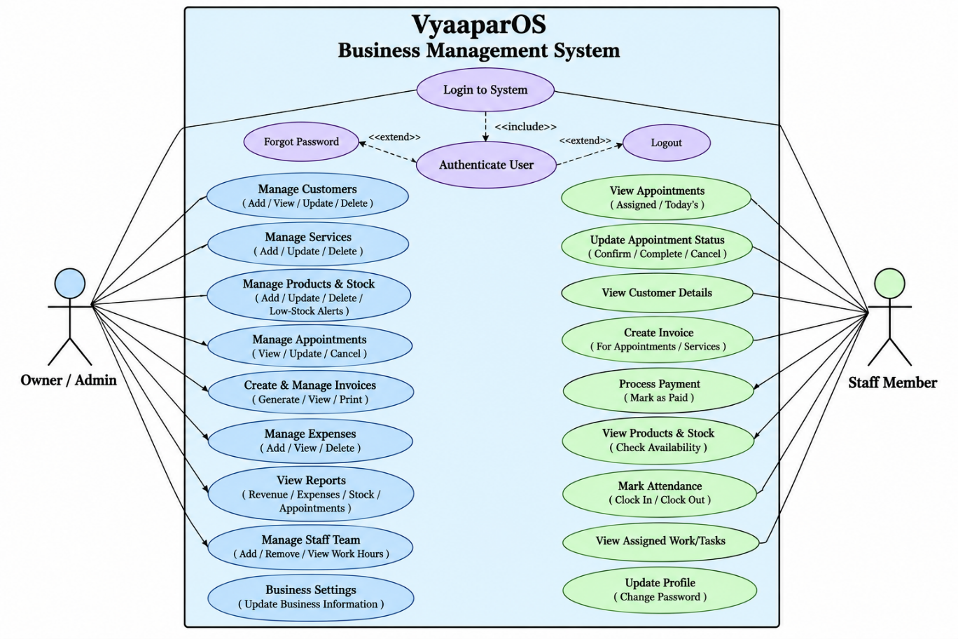

Figure: Use Case Diagram of VyaaparOS – Business Management System

21

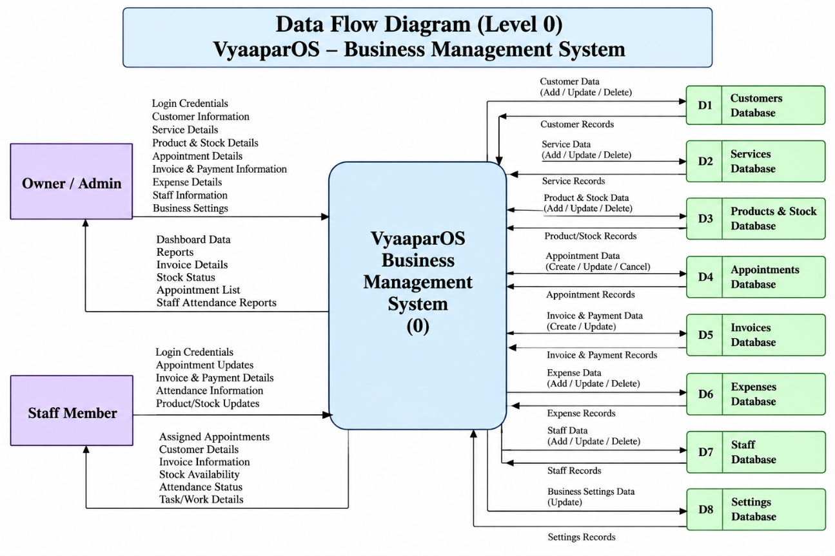

Figure: Data Flow Diagram (Level 0) of VyaaparOS – Business Management System
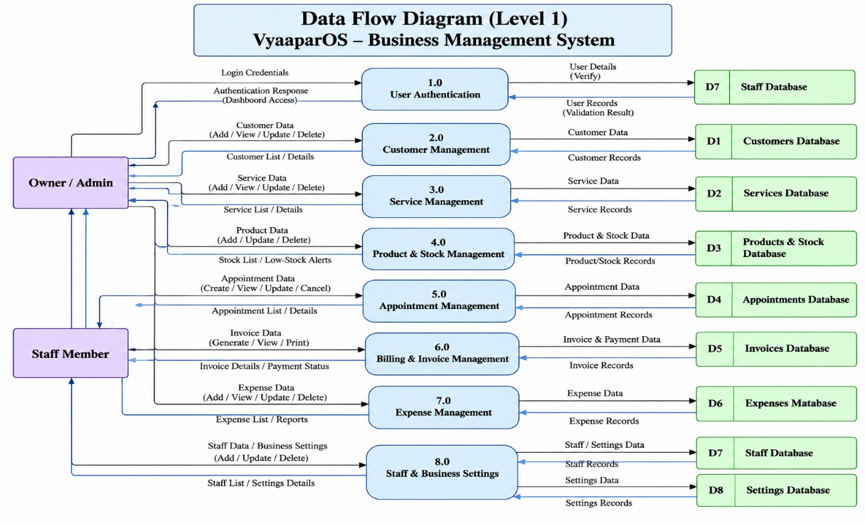

Figure: Data Flow Diagram (Level 1) of VyaaparOS – Business Management System

22

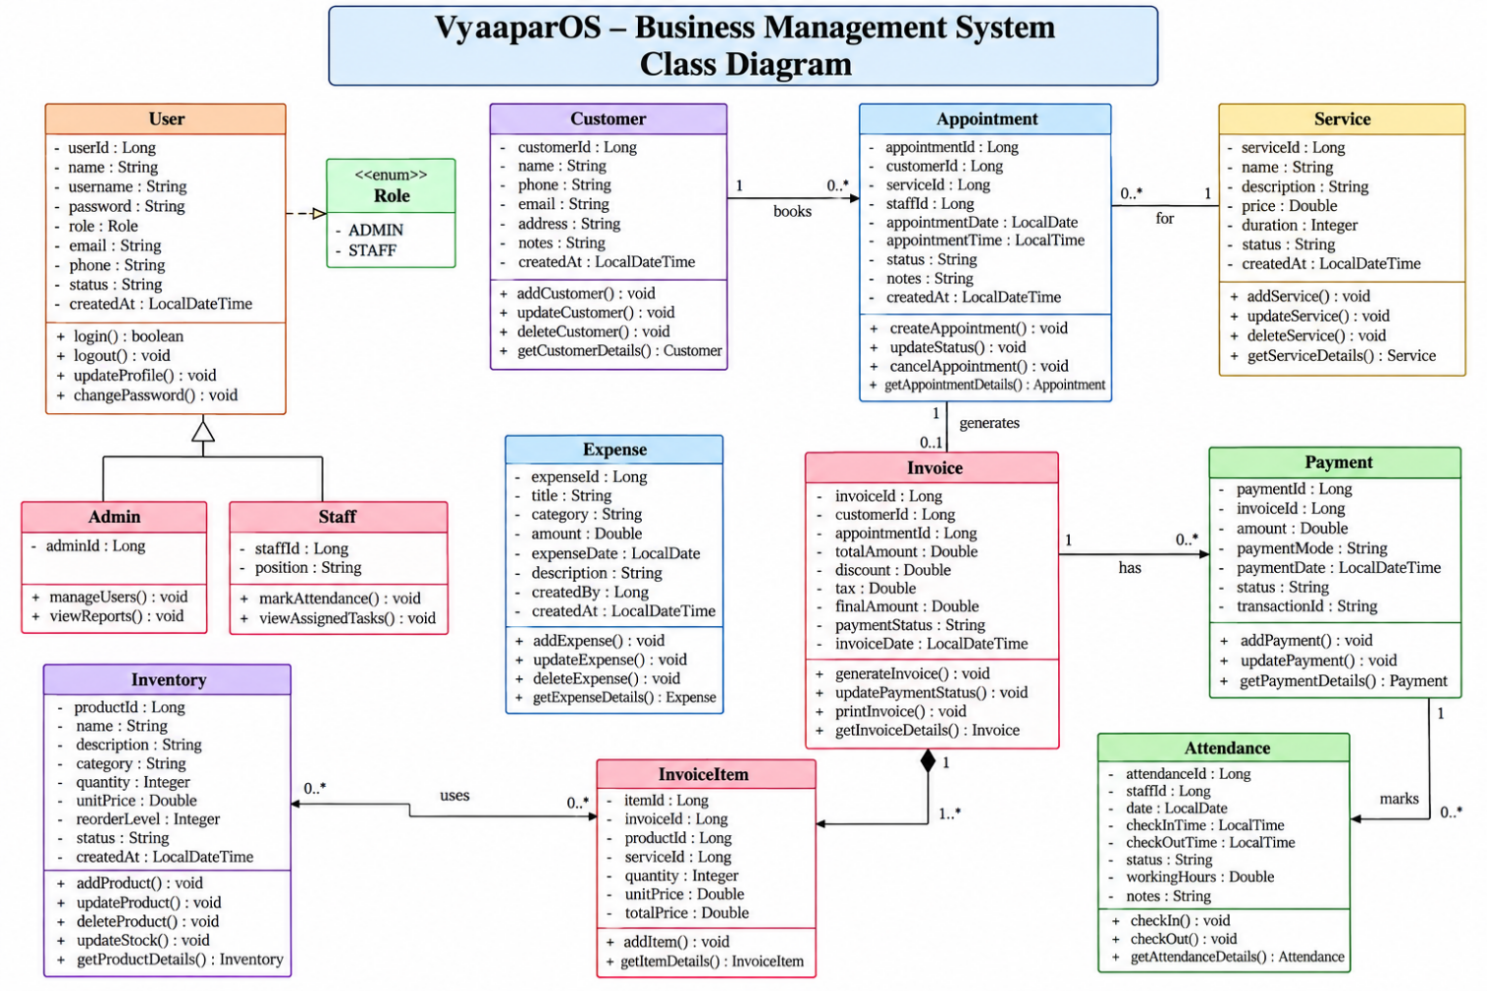

Figure: Class Diagram of VyaaparOS – Business Management System

23
Appendix B: Core Source Code (Java)
package com.vyparos.vyparos.security;
import io.jsonwebtoken.Claims;
import io.jsonwebtoken.JwtException;
import io.jsonwebtoken.Jwts;
import io.jsonwebtoken.security.Keys;
import org.slf4j.Logger;
import org.slf4j.LoggerFactory;
import org.springframework.beans.factory.annotation.Value;
import org.springframework.stereotype.Component;
import javax.crypto.SecretKey;
import java.nio.charset.StandardCharsets;
import java.util.Date;
@Component
public class JwtTokenProvider {
private static final Logger log = LoggerFactory.getLogger(JwtTokenProvider.class);
private final SecretKey key;
private final long jwtExpirationMs;
public JwtTokenProvider(
@Value("${app.jwt.secret}") String jwtSecret,
@Value("${app.jwt.expiration-ms}") long jwtExpirationMs) {
this.key = Keys.hmacShaKeyFor(jwtSecret.getBytes(StandardCharsets.UTF_8));
this.jwtExpirationMs = jwtExpirationMs;
}

public String generateToken(Long userId, String email) {
Date now = new Date();
Date expiryDate = new Date(now.getTime() + jwtExpirationMs);

return Jwts.builder()
.subject(userId.toString())
.claim("email", email)
.issuedAt(now)
.expiration(expiryDate)
.signWith(key)
.compact();
}
public Long getUserIdFromJWT(String token) {
Claims claims = Jwts.parser()
.verifyWith(key)
.build()
24
.parseSignedClaims(token)
.getPayload();

return Long.parseLong(claims.getSubject());
}
public boolean validateToken(String authToken) {
try {
Jwts.parser().verifyWith(key).build().parseSignedClaims(authToken);
return true;
} catch (JwtException | IllegalArgumentException ex) {
log.warn("Invalid JWT token: {}", ex.getMessage());
}
return false;
}
public long getExpirationMs() {
return jwtExpirationMs;
}
}
package com.vyparos.vyparos.security;
import io.jsonwebtoken.Claims;
import io.jsonwebtoken.JwtException;
import io.jsonwebtoken.Jwts;
import io.jsonwebtoken.security.Keys;
import org.slf4j.Logger;
import org.slf4j.LoggerFactory;
import org.springframework.beans.factory.annotation.Value;
import org.springframework.stereotype.Component;
import javax.crypto.SecretKey;
import java.nio.charset.StandardCharsets;
import java.util.Date;
@Component
public class JwtTokenProvider {
private static final Logger log = LoggerFactory.getLogger(JwtTokenProvider.class);
private final SecretKey key;
private final long jwtExpirationMs;
public JwtTokenProvider(
@Value("${app.jwt.secret}") String jwtSecret,
@Value("${app.jwt.expiration-ms}") long jwtExpirationMs) {
this.key = Keys.hmacShaKeyFor(jwtSecret.getBytes(StandardCharsets.UTF_8));
this.jwtExpirationMs = jwtExpirationMs;
25
public String generateToken(Long userId, String email) {
Date now = new Date();
Date expiryDate = new Date(now.getTime() + jwtExpirationMs);

return Jwts.builder()
.subject(userId.toString())
.claim("email", email)
.issuedAt(now)
.expiration(expiryDate)
.signWith(key)
.compact();
}

public Long getUserIdFromJWT(String token) {
Claims claims = Jwts.parser()
.verifyWith(key)
.build()
.parseSignedClaims(token)
.getPayload();

return Long.parseLong(claims.getSubject());
}

public boolean validateToken(String authToken) {
try {
Jwts.parser().verifyWith(key).build().parseSignedClaims(authToken);
return true;
} catch (JwtException | IllegalArgumentException ex) {
log.warn("Invalid JWT token: {}", ex.getMessage());
}
return false;
}

public long getExpirationMs() {
return jwtExpirationMs;
}
}

26
package com.vyparos.vyparos.security;

import com.vyparos.vyparos.identity.entity.User;
import com.vyparos.vyparos.identity.repository.UserRepository;
import org.springframework.security.core.userdetails.UserDetails;
import org.springframework.security.core.userdetails.UserDetailsService;
import org.springframework.security.core.userdetails.UsernameNotFoundException;
import org.springframework.stereotype.Service;
import org.springframework.transaction.annotation.Transactional;

@Service
public class CustomUserDetailsService implements UserDetailsService {

private final UserRepository userRepository;

public CustomUserDetailsService(UserRepository userRepository) {
this.userRepository = userRepository;
}

@Override
@Transactional(readOnly = true)
public UserDetails loadUserByUsername(String email) throws UsernameNotFoundException {
User user = userRepository.findByEmailIgnoreCase(email)
.orElseThrow(() -> new UsernameNotFoundException("User not found with email: " + email));
return UserPrincipal.create(user);
}

@Transactional(readOnly = true)
public UserDetails loadUserById(Long id) {
User user = userRepository.findById(id)
.orElseThrow(() -> new UsernameNotFoundException("User not found with id: " + id));
return UserPrincipal.create(user);
}
}
package com.vyparos.vyparos.security;

import jakarta.servlet.FilterChain;
import jakarta.servlet.ServletException;
import jakarta.servlet.http.HttpServletRequest;

27
import jakarta.servlet.http.HttpServletResponse;
import org.springframework.security.authentication.UsernamePasswordAuthenticationToken;
import org.springframework.security.core.context.SecurityContextHolder;
import org.springframework.security.core.userdetails.UserDetails;
import org.springframework.security.web.authentication.WebAuthenticationDetailsSource;
import org.springframework.stereotype.Component;
import org.springframework.util.StringUtils;
import org.springframework.web.filter.OncePerRequestFilter;

import java.io.IOException;

@Component
public class JwtAuthenticationFilter extends OncePerRequestFilter {

private final JwtTokenProvider tokenProvider;
private final CustomUserDetailsService customUserDetailsService;

public JwtAuthenticationFilter(JwtTokenProvider tokenProvider, CustomUserDetailsService customUserDetailsService) {
this.tokenProvider = tokenProvider;
this.customUserDetailsService = customUserDetailsService;
}

@Override
protected void doFilterInternal(HttpServletRequest request, HttpServletResponse response, FilterChain filterChain)
throws ServletException, IOException {
try {
String jwt = getJwtFromRequest(request);

if (StringUtils.hasText(jwt) && tokenProvider.validateToken(jwt)) {
Long userId = tokenProvider.getUserIdFromJWT(jwt);
UserDetails userDetails = customUserDetailsService.loadUserById(userId);

UsernamePasswordAuthenticationToken authentication =
new UsernamePasswordAuthenticationToken(userDetails, null, userDetails.getAuthorities());
authentication.setDetails(new WebAuthenticationDetailsSource().buildDetails(request));

SecurityContextHolder.getContext().setAuthentication(authentication);
}
} catch (Exception ex) {
logger.error("Could not set user authentication in security context", ex);
}

filterChain.doFilter(request, response);
28
private String getJwtFromRequest(HttpServletRequest request) {
String bearerToken = request.getHeader("Authorization");
if (StringUtils.hasText(bearerToken) && bearerToken.startsWith("Bearer ")) {
return bearerToken.substring(7);
}
return null;
}
}
server:
port: ${SERVER_PORT:8080}
error:
include-message: always
include-binding-errors: always

spring:
application:
name: vyparos-backend
profiles:
active: ${SPRING_PROFILES_ACTIVE:dev}
datasource:
url: ${SPRING_DATASOURCE_URL:jdbc:mysql://${DB_HOST:localhost}:${DB_PORT:3306}/${DB_NAME:vyparos_db}?useSSL=false&allowPublicKeyRetrieval=true&serverTimezone=UTC}
username: ${DB_USERNAME:root}
password: ${DB_PASSWORD:root}
driver-class-name: com.mysql.cj.jdbc.Driver

# Application-specific Security and JWT Configurations
app:
jwt:
secret: ${JWT_SECRET}
expiration-ms: ${JWT_EXPIRATION_MS:86400000} # 24 hours
cors:
allowed-origins: ${CORS_ALLOWED_ORIGINS:http://localhost:*,http://127.0.0.1:*,https://*.vercel.app,https://*.netlify.app}

29
7. REFERENCES

[1] Spring Boot Reference Documentation. Available at: Spring Boot Documentation

[2] Spring Data JPA Reference Documentation. Available at: Spring Data JPA Documentation

[3] Oracle, Java Platform, Standard Edition (Java SE) Documentation. Available at:Java Documentation

[4] MySQL Reference Manual. Available at: MySQL Documentation

[5] Mozilla Developer Network (MDN), HTML Documentation. Available at:HTML Documentation

[6] Mozilla Developer Network (MDN), CSS Documentation. Available at: CSS Documentation

[7] Mozilla Developer Network (MDN), JavaScript Documentation. Available at:JavaScript Documentation

[8] Bootstrap Documentation. Available at: Bootstrap Documentation

[9] GitHub Documentation. Available at: GitHub Docs

[10] Apache Maven Project, Maven Documentation. Available at: Apache Maven Documentation

[11] Mermaid, Diagramming and Charting Tool Documentation. Available at:Mermaid Documentation

[12] VyaaparOS, Business Management System — Project Website. Available at: VyaaparOS Website

30

